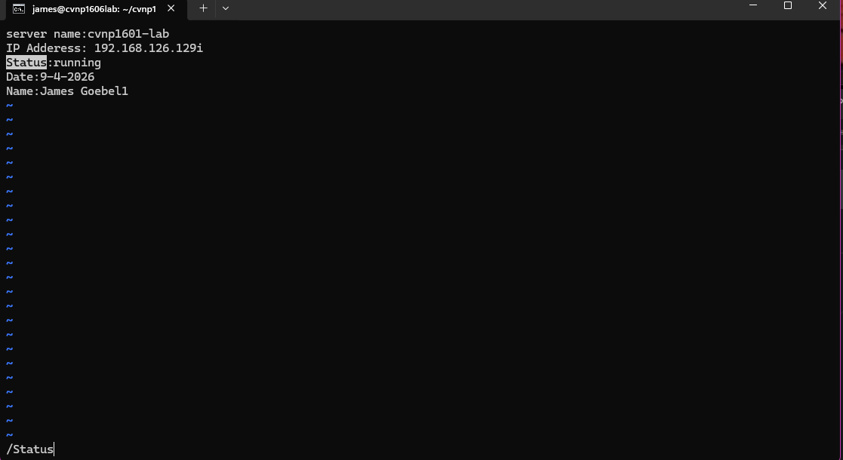
Vim note proof 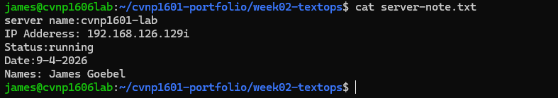
:q! is a way to force your self out of text editing and not save anything preserving the file how it was before you made any edits.
Nano snip 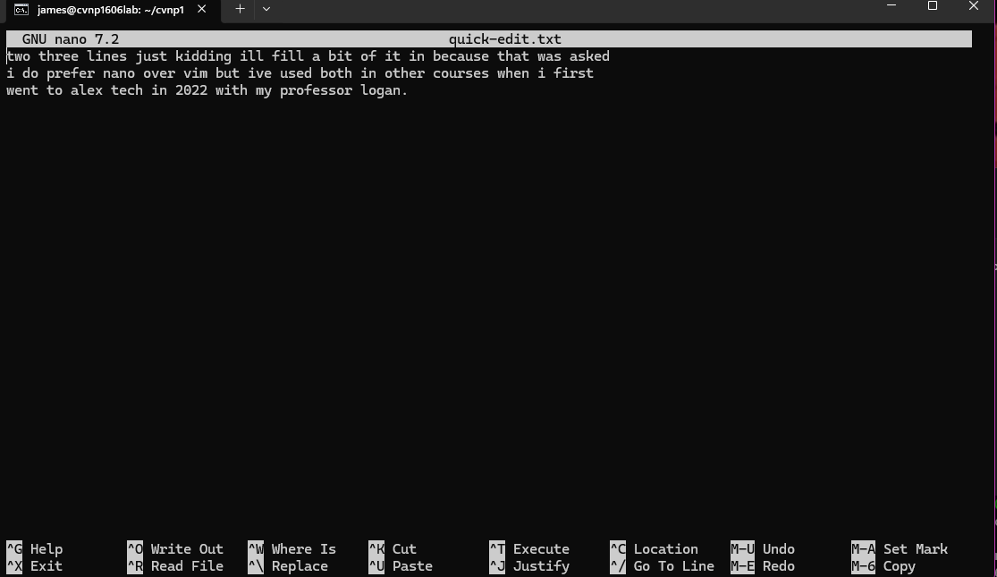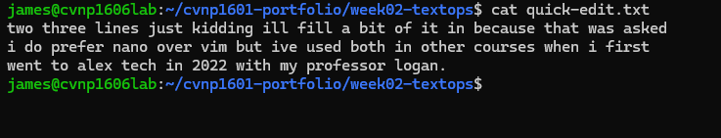
Nano is preferred over vim for simplicity sake it keeps everything in near quick hotkey fashion instead of having to i in and then esc to a :w or :q the search function is nice in vim but everything else nano does over shadows it as well as still doing search.
Ran the first command
Ran the others and then ran the ssh config 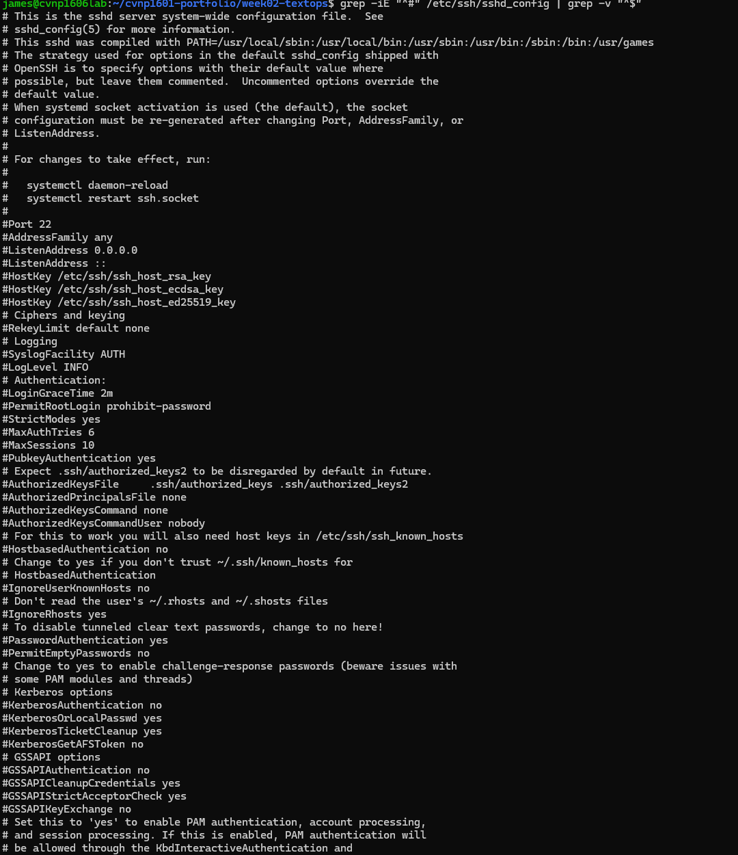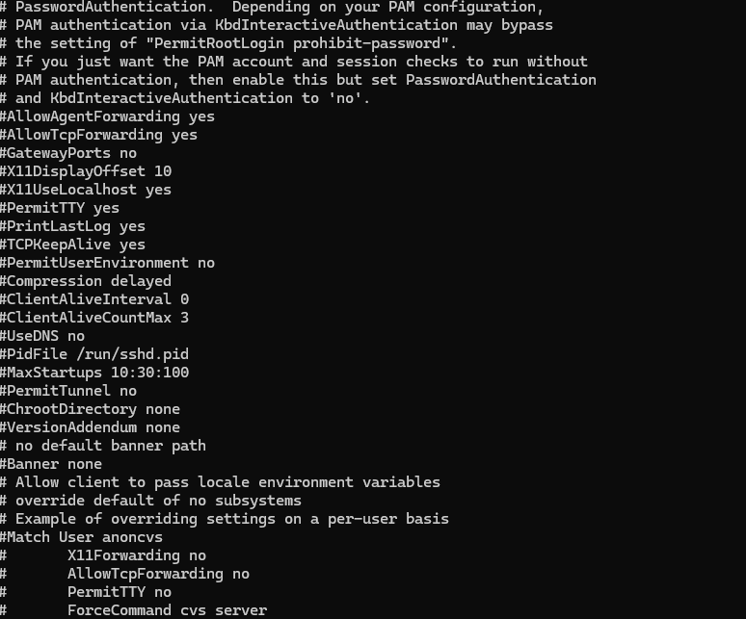
Grep-v explanation a doubele grep -v works by linking 2 consecutive inverted searches using a | pipe to filter out unwanted lines the first grep -v excludes all lines containg the first term and the same goes for the second removes the second good for log filtering

Evidence for awk extraction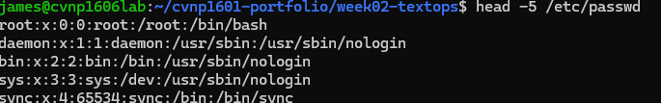
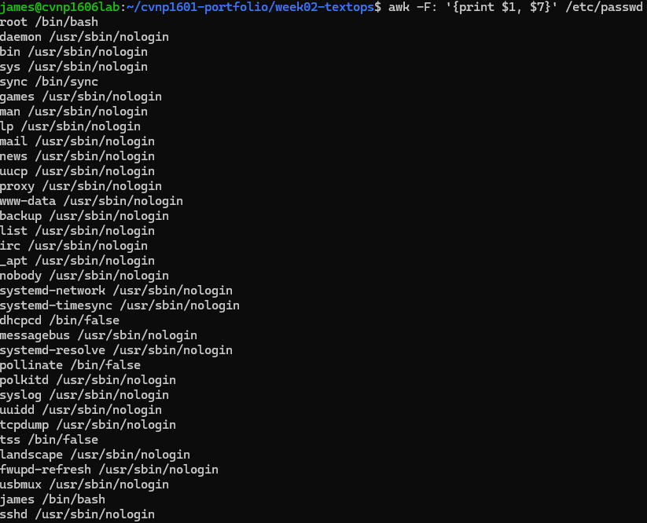
Explanation -f option tells awk to use a : as a field separator because /etc/passwd stores info in the separated fields it allows awk to access them individually for example $1 for user name $3 and $7 for login shell

Access report evidence 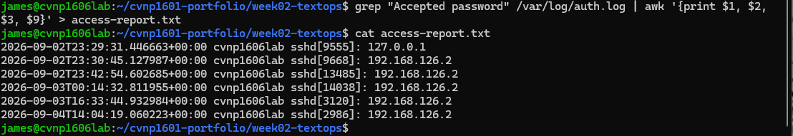
The written field count spit out 12
Week 2 cheatsheet update in a cat display 